# Stock Exchange Simulation

**Diagram(LTS):**

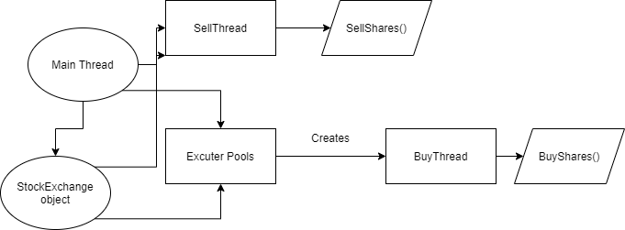

**Avoiding Race Conditions mechanisms:**

We have used synchronized key word in function header of those which we want to run concurrently this will initiate a mutual exclusion mechanism. e.g.

synchronized public Boolean registerCompany(Company company, float numberOfShares)

This will prevent the race conditions for example if two threads are running concurrently no one can intervene in their resources. So following this mechanism we can avoid race conditions.

**Avoid dead lock:**

If the program crashes due to dead lock we have implemented exceptions that will prevent the program from crashing and moreover we have disturbed data for each thread and a single source of truth for stockExchange that will be synchronized and prevent any sort of dead lock.